Spring Security Basics 2
https://www.baeldung.com/role-and-privilege-for-spring-security-registration
https://stackoverflow.com/questions/19525380/difference-between-role-and-grantedauthority-in-spring-security

https://stackoverflow.com/questions/20963273/spa-best-practices-for-authentication-and-session-management

https://stackoverflow.com/questions/549/the-definitive-guide-to-form-based-website-authentication

Bean?
PasswordEncoder?
Recommended way for injections?

Asd

Forms Authentication
This is the most used form of authentication (?).
We need to create a custom login form which we will later use to check and authenticate the user.
We are using a lot of conventions:
- In order to authenticate we need to send a POST request to /login.
- The id and name attributes of <input> must both be ‘name’ and ‘password’
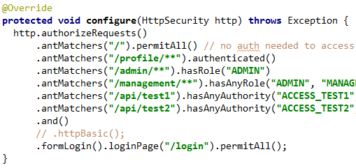
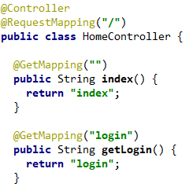

This works correctly now, we can go to /login and enter our credentials.
- After we login, we are redirected to the homepage.
- If we try to access a resource (/admin) without logging in, the app redirects us to /login.
- The authentication logic is implemented by spring security by default. Nowhere in our code we do anything with a POST request to /login, we only handle a GET to return the login page.
- After successful login we will get a session id (cookie) JSESSIONID as we saw before with http basic auth.

Logout
We are adding a button to our page, again a form with a POST method to /logout, the default convention of spring security.

We also need to configure spring security to be aware of the logout function.
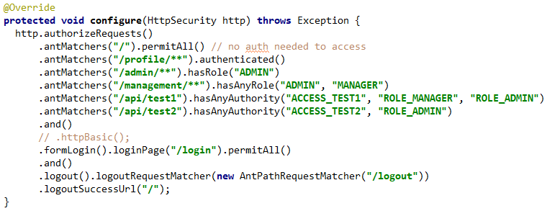

HTTP Cookies
An HTTP cookie (web cookie, browser cookie) is a small piece of data that a server sends to the user's web browser. The browser may store it and send it back with the next request to the same server. Typically, it's used to tell if two requests came from the same browser — keeping a user logged-in, for example. It remembers stateful information for the stateless HTTP protocol. Cookies are mainly used for three purposes:
- Session management: Logins, shopping carts, game scores, or anything else the server should remember
- Personalization: User preferences, themes, and other settings
- Tracking: Recording and analyzing user behavior
Cookies were once used for general client-side storage. While this was legitimate when they were the only way to store data on the client, it is recommended nowadays to prefer modern storage APIs. Cookies are sent with every request, so they can worsen performance (especially for mobile data connections). Modern APIs for client storage are the Web storage API (localStorage and sessionStorage) and IndexedDB.

Creating cookies
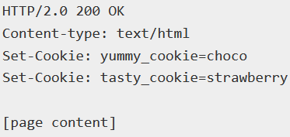
When receiving an HTTP request, a server can send a Set-Cookie header with the response. The cookie is usually stored by the browser, and then the cookie is sent with requests made to the same server inside a Cookie HTTP header. An expiration date or duration can be specified, after which the cookie is no longer sent. Additionally, restrictions to a specific domain and path can be set, limiting where the cookie is sent.

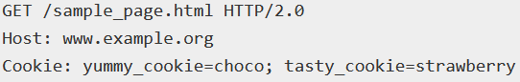
Now, with every new request to the server, the browser will send back all previously stored cookies to the server using the Cookie header.

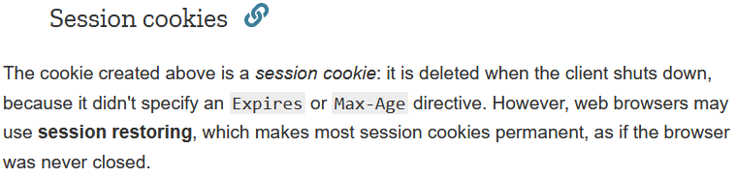

Permanent cookies
Instead of expiring when the client closes, permanent cookies expire at a specific date (Expires) or after a specific length of time (Max-Age).

- When an expiry date is set, the time and date set is relative to the client the cookie is being set on, not the server.

Secure and HttpOnly cookies
A secure cookie is only sent to the server with an encrypted request over the HTTPS protocol. Even with Secure, sensitive information should never be stored in cookies, as they are inherently insecure and this flag can't offer real protection. Starting with Chrome 52 and Firefox 52, insecure sites (http:) can't set cookies with the Secure directive.
To help mitigate cross-site scripting (XSS) attacks, HttpOnly cookies are inaccessible to JavaScript's Document.cookie API; they are only sent to the server. For example, cookies that persist server-side sessions don't need to be available to JavaScript, and the HttpOnly flag should be set.

Scope of cookies
The Domain and Path directives define the scope of the cookie: what URLs the cookies should be sent to.
Domain specifies allowed hosts to receive the cookie. If unspecified, it defaults to the host of the current document location, excluding subdomains. If Domain is specified, then subdomains are always included.
- For example, if Domain=mozilla.org is set, then cookies are included on subdomains like developer.mozilla.org.

Path indicates a URL path that must exist in the requested URL in order to send the Cookie header. The %x2F ("/") character is considered a directory separator, and subdirectories will match as well.
For example, if Path=/docs is set, these paths will match:
- /docs
- /docs/Web/
- /docs/Web/HTTP

SameSite Cookies
SameSite cookies let servers require that a cookie shouldn't be sent with cross-site (where Site is defined by the registrable domain) requests, which provides some protection against cross-site request forgery attacks (CSRF). SameSite cookies are relatively new and supported by all major browsers. Here is an example:
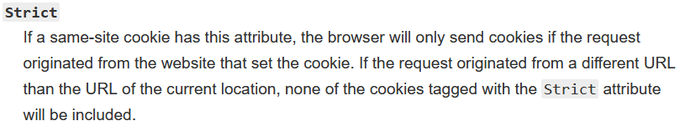
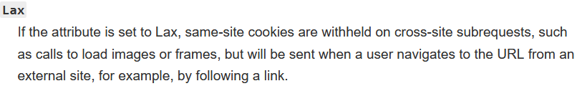

The default behavior if the flag is not set, or not supported by the browser, is to include the cookies in any request, including cross-origin requests.

JavaScript access using Document.cookie
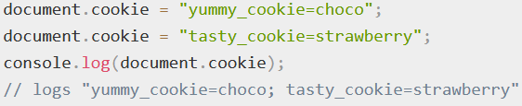
New cookies can also be created via JavaScript using the Document.cookie property, and if the HttpOnly flag is not set, existing cookies can be accessed from JavaScript as well.
- Cookies created via JavaScript cannot include the HttpOnly flag.
- Cookies available to JavaScript can be stolen through XSS.

Cross-site request forgery (CSRF)
There are a few techniques that should be used to prevent this from happening:
- GET endpoints should be idempotent
- A CSRF token should be included in <form> elements via a hidden input field. This token should be unique per user and stored (for example, in a cookie) such that the server can look up the expected value when the request is sent. For all non-GET requests that have the potential to perform an action, this input field should be compared against the expected value. If there is a mismatch, the request should be aborted.
  - This method of protection relies on an attacker being unable to predict the user's assigned CSRF token. The token should be regenerated on sign-in.
- Cookies that are used for sensitive actions (such as session cookies) should have a short lifetime with the SameSite attribute set to Strict or Lax. (See SameSite cookies above). In supporting browsers, this will have the effect of ensuring that the session cookie is not sent along with cross-site requests and so the request is effectively unauthenticated to the application server.
- Both CSRF tokens and SameSite cookies should be deployed. This ensures all browsers are protected and provides protection where SameSite cookies cannot help (such as attacks originating from a separate subdomain).
- For more prevention tips, see the OWASP CSRF prevention cheat sheet.

TODO: Cookie prefixes

Tracking and privacy
Third-party cookies
Cookies have a domain associated to them. If this domain is the same as the domain of the page you are on, the cookies is said to be a first-party cookie. If the domain is different, it is said to be a third-party cookie. While first-party cookies are sent only to the server setting them, a web page may contain images or other components stored on servers in other domains (like ad banners). Cookies that are sent through these third-party components are called third-party cookies and are mainly used for advertising and tracking across the web. See for example the types of cookies used by Google. Most browsers allow third-party cookies by default, but there are add-ons available to block them (for example, Privacy Badger by the EFF).
If you are not disclosing third-party cookies, consumer trust might get harmed if cookie use is discovered. A clear disclosure (such as in a privacy policy) tends to eliminate any negative effects of a cookie discovery. Some countries also have legislation about cookies. See for example Wikimedia Foundation's cookie statement.

Do-Not-Track
There are no legal or technological requirements for its use, but the DNT header can be used to signal that a web application should disable either its tracking or cross-site user tracking of an individual user.

EU cookie directive
Requirements for cookies across the EU are defined in Directive 2009/136/EC of the European Parliament and came into effect on 25 May 2011. A directive is not a law by itself, but a requirement for EU member states to put laws in place that meet the requirements of the directive. The actual laws can differ from country to country.
In short the EU directive means that before somebody can store or retrieve any information from a computer, mobile phone or other device, the user must give informed consent to do so. Many websites have added banners (AKA "cookie banners") since then to inform the user about the use of cookies.

Zombie cookies and Evercookies
A more radical approach to cookies are zombie cookies or "Evercookies" which are recreated after their deletion and are intentionally hard to delete forever. They are using the Web storage API, Flash Local Shared Objects and other techniques to recreate themselves whenever the cookie's absence is detected.

Fingerprinters
If you wonder why you keep seeing the same ad, over and over, the answer could be fingerprinting. Fingerprinting is a type of online tracking that’s different from cookies or ordinary trackers. This digital fingerprint is created when a company makes a unique profile of your computer, software, add-ons, and even preferences. Your settings like the screen you use, the fonts installed on your computer, and even your choice of a web browser can all be used to create a fingerprint.
Remember Me
Every time a user visits our application (close the browser and open a new one), they have to re-login. Because all session cookies are deleted. Spring security has 2 options for us:
- Store the Remember-Me token in a Cookie (default)
- Store the token in a Database

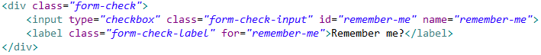
Adding a checkbox. Name is important (?) remember-me

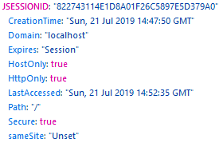
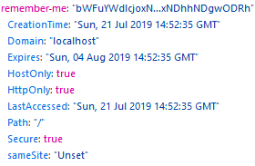
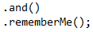

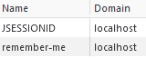

The only difference between these cookies is the expiration date.
JsessionId has Expires: “Session”, meaning that it will expire when the window is closed or a logout.
Remember-me cookies have a 2 week expiration date by default.

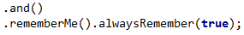
- With this you don’t need a checkbox. It will always send the remember me cookie.

TODO: When I login with remember-me, delete the JsessionId and send a new request this exception is thrown:
java.lang.IllegalStateException: UserDetailsService is required.
When I delete the remember-me cookie and try again, it works.

Store Remember Me to Database
TODO: Why and how?

JWT
Explain what jwt is, where to use etc.

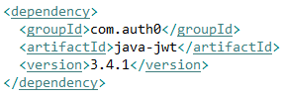
Dependencies
For convenience we will use everything in a single app.
This library makes working with JWT easier. There are many more options and we could also choose another one.

Authentication

